Schema GridHostingCapacityDocument_v1.12.35_annotated.xsd

complexType Cadastre
diagram | 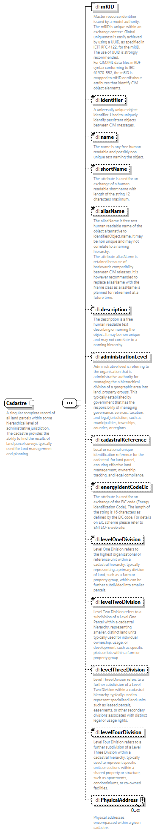
annotation
  documentation
  A singular complete record of all land parcels within some hierarchical level of administrative jurisdiction. The cadastre provides the ability to find the results of land parcel surveys typically used for land management and planning.
  documentation
  New
  documentation
  MBIE

complexType Circle
diagram | 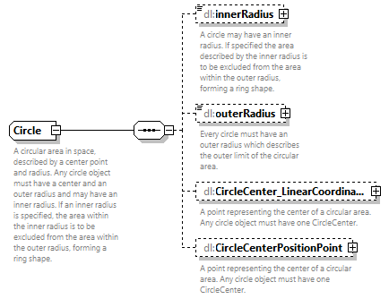
annotation
  documentation
  A circular area in space, described by a center point and radius. Any circle object must have a center and an outer radius and may have an inner radius. If an inner radius is specified, the area within the inner radius is to be excluded from the area within the outer radius, forming a ring shape.
  documentation
  New
  documentation
  MBIE

complexType EnvAsset
diagram | 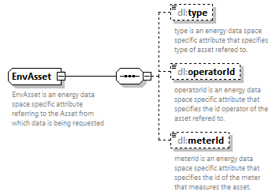
annotation
  documentation
  EnvAsset is an energy data space specific attribute referring to the Asset from which data is being requested
  documentation
  documentation
  MBIE

complexType ESMP_ActivePower
diagram | 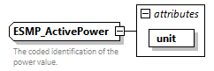
type | extension of dl:ESMP_ActivePower-base
attributes
  Name | Type | Use | Default | Fixed | Annotation
  unit | ecl:UnitSymbol | required |  | MAW
annotation
  documentation
  The coded identification of the power value.
  documentation
  CIMDatatype

complexType ESMP_Length
diagram | 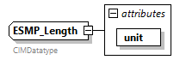
type | extension of dl:ESMP_Length-base
attributes
  Name | Type | Use | Default | Fixed | Annotation
  unit | ecl:UnitSymbol | required |  | MTR
annotation
  documentation
  CIMDatatype

complexType ESMP_NominalMinMax
diagram | 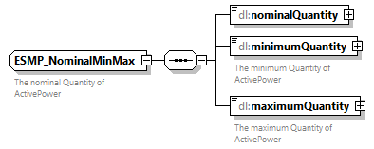
annotation
  documentation
  The nominal Quantity of ActivePower
  documentation
  Compound
  documentation
  CEEDS

complexType ESMP_Voltage
diagram | 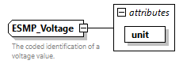
type | extension of dl:ESMP_Voltage-base
attributes
  Name | Type | Use | Default | Fixed | Annotation
  unit | ecl:UnitSymbol | required |  | KVT
annotation
  documentation
  The coded identification of a voltage value.
  documentation
  CIMDatatype

complexType Geometry
diagram | 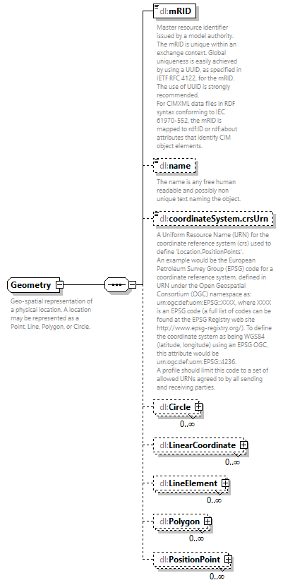
annotation
  documentation
  Geo-spatial representation of a physical location. A location may be represented as a Point, Line, Polygon, or Circle.
  documentation
  New
  documentation
  MBIE

complexType GHC_Envelope
diagram | 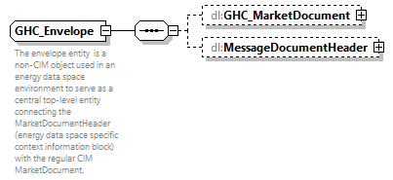
annotation
  documentation
  The envelope entity is a non-CIM object used in an energy data space environment to serve as a central top-level entity connecting the MarketDocumentHeader (energy data space specific context information block) with the regular CIM MarketDocument.
  documentation
  documentation
  MBIE
  documentation
  CEEDS

complexType GHC_MarketDocument
diagram | 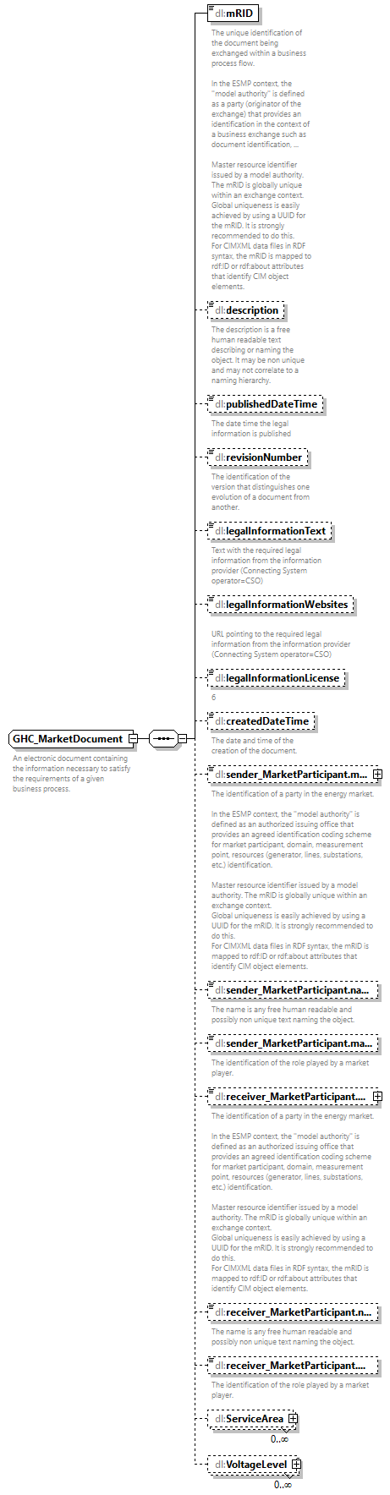
annotation
  documentation
  An electronic document containing the information necessary to satisfy the requirements of a given business process.
  documentation
  MBIE

complexType HostingCapacity
diagram | 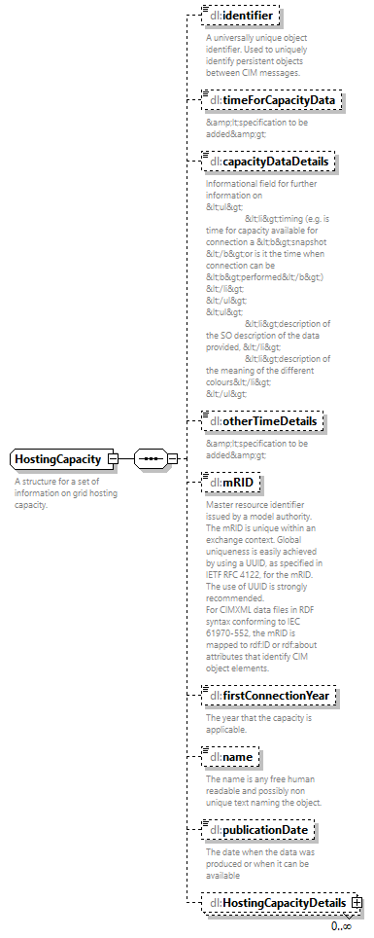
annotation
  documentation
  A structure for a set of information on grid hosting capacity.
  documentation
  MBIE

complexType HostingCapacityDetail
diagram | 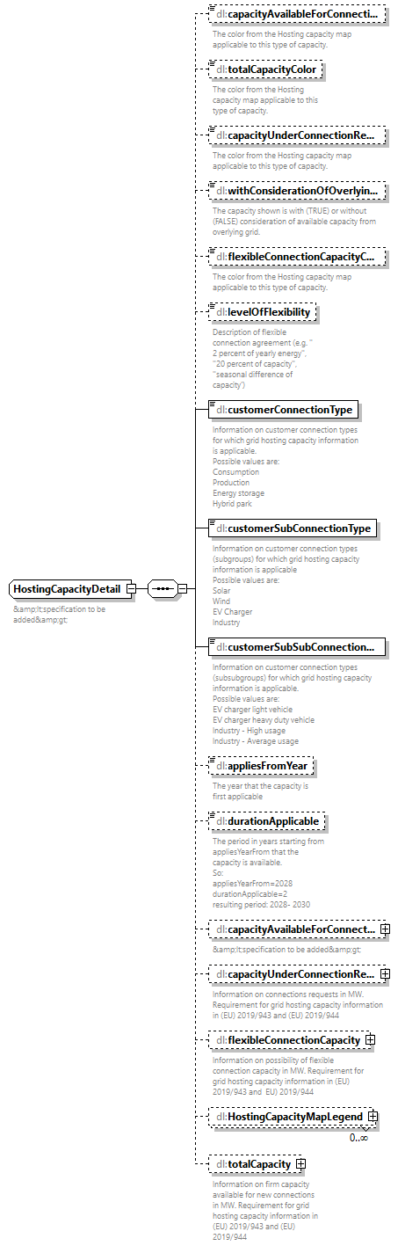
annotation
  documentation
  &amp;lt;specification to be added&amp;gt;
  documentation
  MBIE

complexType HostingCapacityMapLegend
diagram | 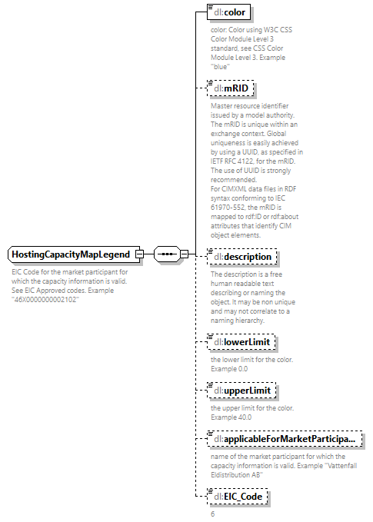
annotation
  documentation
  EIC Code for the market participant for which the capacity information is valid. See EIC Approved codes. Example "46X0000000002102"
  documentation
  MBIE

complexType LinearCoordinate
diagram | 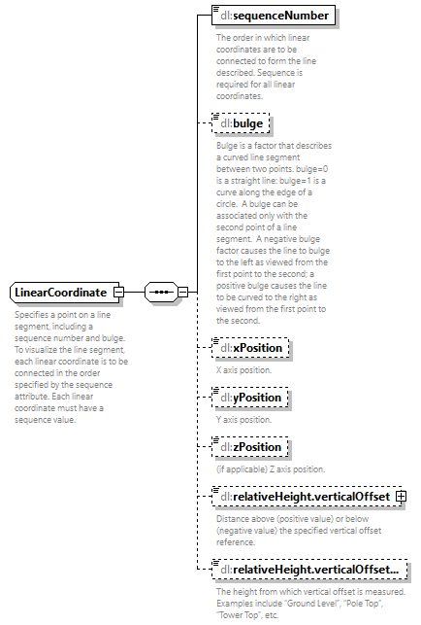
annotation
  documentation
  Specifies a point on a line segment, including a sequence number and bulge. To visualize the line segment, each linear coordinate is to be connected in the order specified by the sequence attribute. Each linear coordinate must have a sequence value.
  documentation
  New
  documentation
  MBIE

complexType LineElement
diagram | 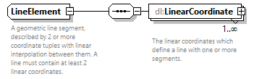
annotation
  documentation
  A geometric line segment, described by 2 or more coordinate tuples with linear interpolation between them. A line must contain at least 2 linear coordinates.
  documentation
  New
  documentation
  MBIE

complexType Location
diagram | 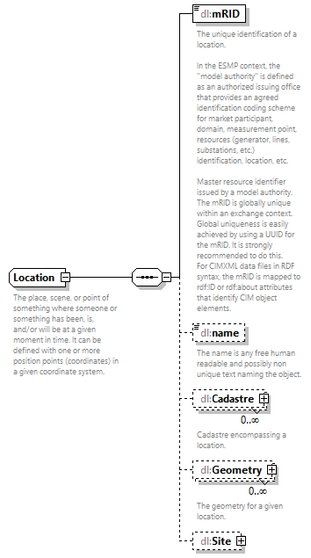
annotation
  documentation
  The place, scene, or point of something where someone or something has been, is, and/or will be at a given moment in time. It can be defined with one or more position points (coordinates) in a given coordinate system.
  documentation
  MBIE

complexType MessageDocumentHeader
diagram | 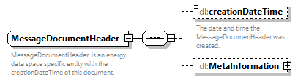
annotation
  documentation
  MessageDocumentHeader is an energy data space specific entity with the creationDateTime of this document.
  documentation
  documentation
  documentation
  MBIE
  documentation
  CEEDS

complexType MetaInformation
diagram | 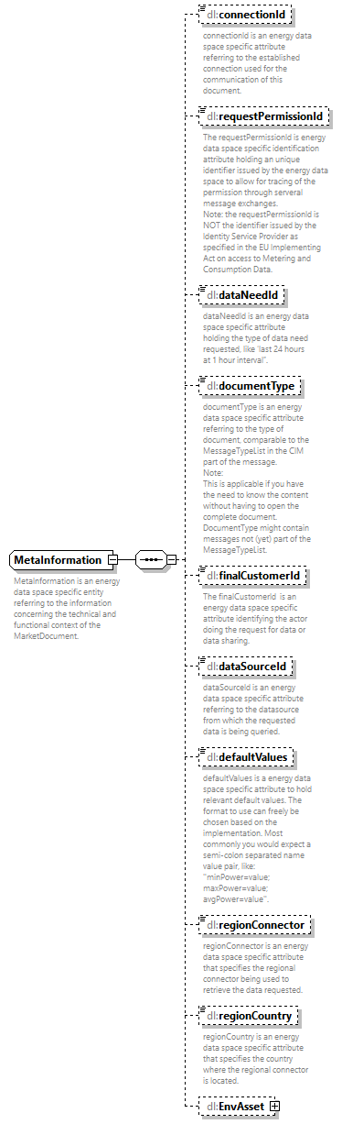
annotation
  documentation
  MetaInformation is an energy data space specific entity referring to the information concerning the technical and functional context of the MarketDocument.
  documentation
  documentation
  documentation
  MBIE
  documentation
  CEEDS

complexType PartyID_String
diagram | 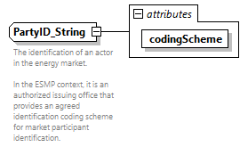
type | extension of dl:PartyID_String-base
attributes
  Name | Type | Use | Default | Fixed | Annotation
  codingScheme | ecl:CodingSchemeTypeList | required
annotation
  documentation
  The identification of an actor in the energy market.
  In the ESMP context, it is an authorized issuing office that provides an agreed identification coding scheme for market participant identification.
  documentation
  PartyType
  documentation
  CIMDatatype

complexType PhysicalAddress
diagram | 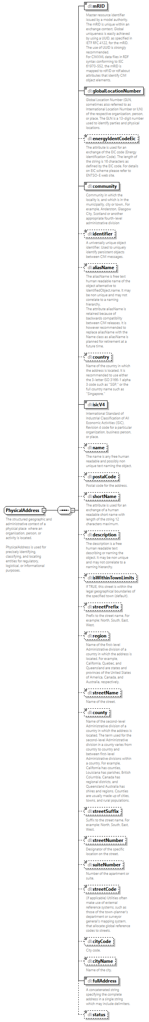
annotation
  documentation
  The structured geographic and administrative context of a physical place where an organisation, person, or activity is located.
  PhysicalAddress is used for precisely identifying, classifying, and locating entities for regulatory, logistical, or informational purposes.
  documentation
  MBIE

complexType Polygon
diagram | 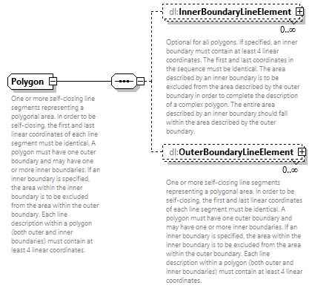
annotation
  documentation
  One or more self-closing line segments representing a polygonal area. In order to be self-closing, the first and last linear coordinates of each line segment must be identical. A polygon must have one outer boundary and may have one or more inner boundaries. If an inner boundary is specified, the area within the inner boundary is to be excluded from the area within the outer boundary. Each line description within a polygon (both outer and inner boundaries) must contain at least 4 linear coordinates.
  documentation
  New
  documentation
  MBIE

complexType PositionPoint
diagram | 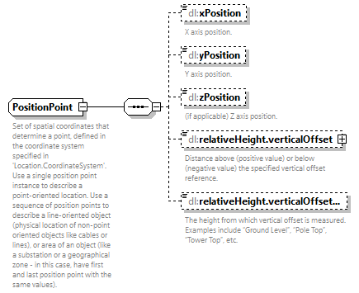
annotation
  documentation
  Set of spatial coordinates that determine a point, defined in the coordinate system specified in 'Location.CoordinateSystem'. Use a single position point instance to describe a point-oriented location. Use a sequence of position points to describe a line-oriented object (physical location of non-point oriented objects like cables or lines), or area of an object (like a substation or a geographical zone - in this case, have first and last position point with the same values).
  documentation
  MBIE

complexType ServiceArea
diagram | 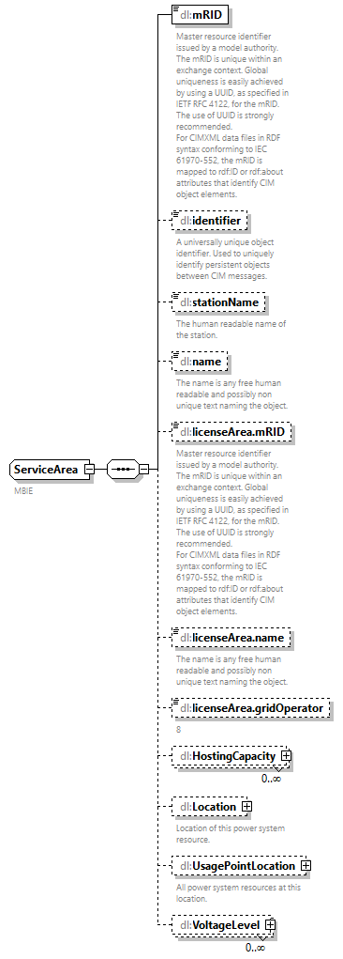
annotation
  documentation
  MBIE

complexType Site
diagram | 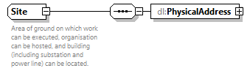
annotation
  documentation
  Area of ground on which work can be executed, organisation can be hosted, and building (including substation and power line) can be located.
  documentation
  MBIE

complexType UsagePointLocation
diagram | 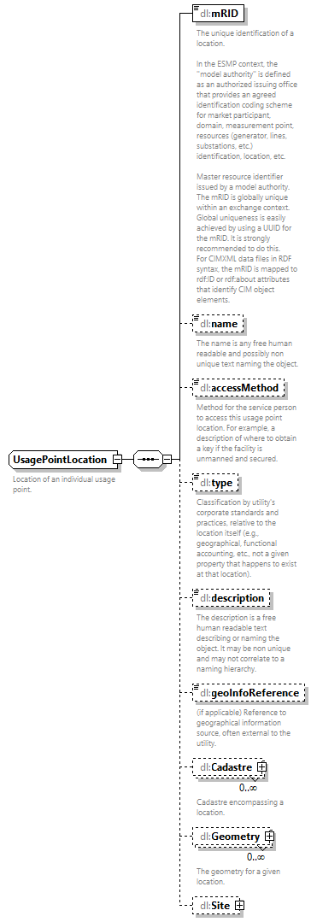
annotation
  documentation
  Location of an individual usage point.
  documentation
  MBIE

complexType VoltageLevel
diagram | 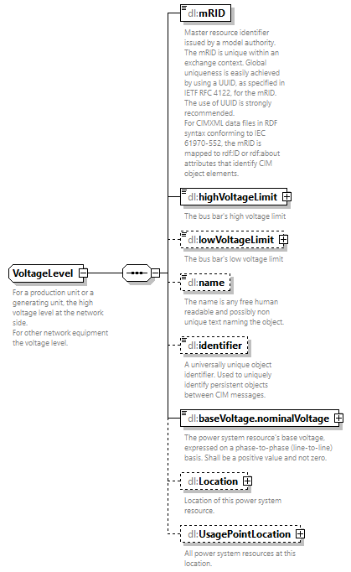
annotation
  documentation
  For a production unit or a generating unit, the high voltage level at the network side.
  For other network equipment the voltage level.
  documentation
  MBIE

simpleType ESMP_ActivePower-base
type | restriction of xs:float

simpleType ESMP_DateTime
type | restriction of xs:dateTime
annotation
  documentation
  In ESMP, the dateTime shall be expressed in UTC as YYYY-MM-DDThh:mm:ssZ.
  documentation
  MessageDateTimeType
  documentation
  CIMDatatype

simpleType ESMP_Float
type | restriction of xs:float
annotation
  documentation
  A floating point number. The range is unspecified and not limited.
  The float value is expressed as a simple precision and no mantisse, i.e. as a decimal for XML.
  documentation
  CIMDatatype

simpleType ESMP_Length-base
type | restriction of xs:float

simpleType ESMP_Voltage-base
type | restriction of xs:float

simpleType ESMPVersion_String
type | restriction of xs:string
annotation
  documentation
  In ESMP, the coded value is restricted to digits.
  A code that distinguishes one evolution of an identified object from another. Information about a specific object may be sent several times, each transmission being identified by a different version number.
  documentation
  VersionType
  documentation
  CIMDatatype

simpleType ID_String
type | restriction of xs:string
annotation
  documentation
  A code to uniquely distinguish one occurrence of an entity from another.
  In the ESMP context, the code is defined either by:
  - an emitting company that provides an agreed identification unique within a business context such as capacity auction identification, market agreement identification, etc.
  - a party (originator of the exchange) that provides a unique identification in the framework of a business exchange such as document identification, time series identification, bid identification, ...
  documentation
  IdentificationType
  documentation
  CIMDatatype

simpleType MarketRoleKind_String
type | ecl:RoleTypeList
annotation
  documentation
  The identification of the role played by a party.
  documentation
  RoleType
  documentation
  CIMDatatype

simpleType PartyID_String-base
type | restriction of xs:string

simpleType Status_String
type | ecl:StatusTypeList
annotation
  documentation
  The identification of the status of an object.
  documentation
  CIMDatatype

XML Schema documentation generated by XMLSpy Schema Editor http://www.altova.com/xmlspy

